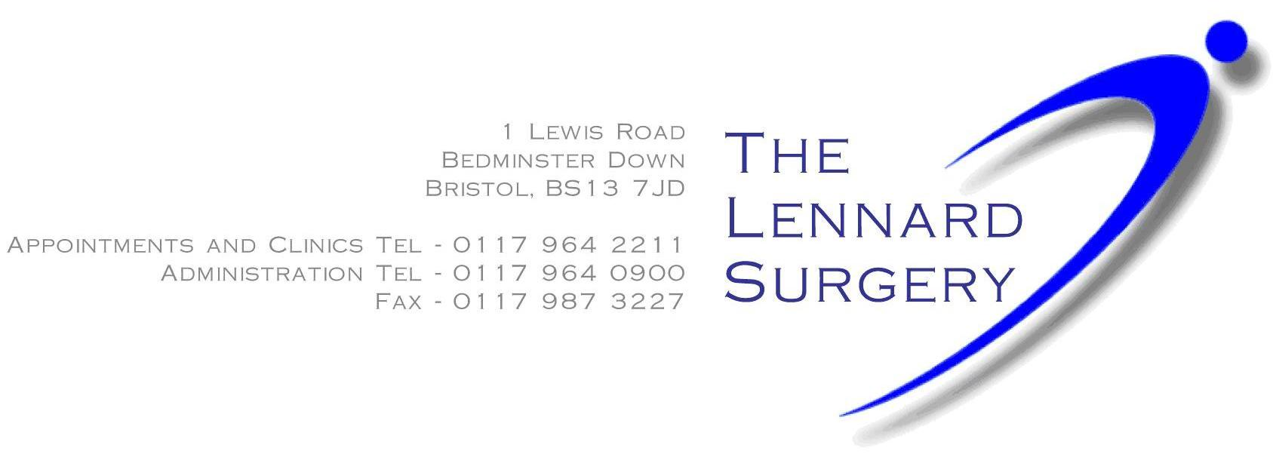

Consent Form

I ………………………………… give permission for ……………………………. to discuss my medical information on my behalf.

Relationship to ……………………………...

Signed ………………………..

Print name …………………………………

Date of Birth ……………………….

Date …………………………..

Office Use only:
Emis Number:

Please hand this form into reception or post through box at front of surgery.

